FUNDRAISER

ALQHA Members Level 2
Sit & Watch
$25
Saddle & Ride
$45

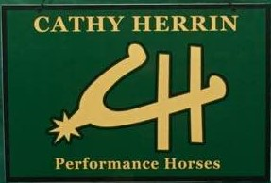
HUS Clinic

Clinician:

March 25, 2017 10 am Until 4 pm

Shoal Creek Stables
495 Jackson Taylor Lane
Ashville, AL 35953
Rhonda Bell: 205-337-5845 Kristi Bowen: 205-332-4463

All Proceeds donated to our ALQHYA!

